AFFIX A
PASSPORT PHOTO
HERE

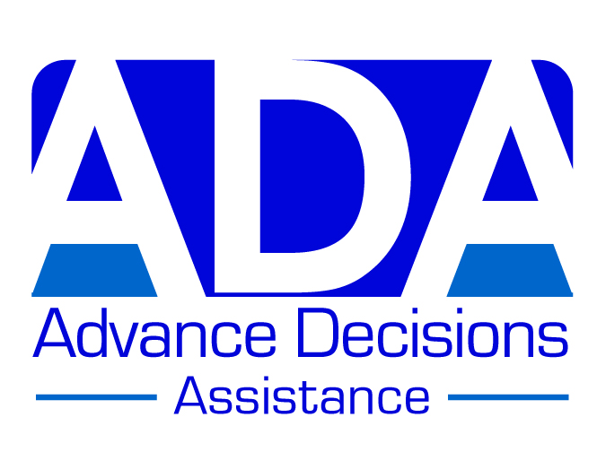

ADVANCE DECISION FORM (VERSION B)

This version is most suitable for someone who is generally healthy, or has a few health problems

Note to person completing this form: If this version is not quite right for you, remember that
you can personalise it by adding or deleting information. You may also like to look at the other versions on the ADA website: www.ADassistance.org.uk. Further information can also be found
on the website; or phone us if you have any questions: 01757 289453

This Advance Decision is intended to apply indefinitely unless I specifically revoke it.
I give permission for anyone legitimately involved in my care to read it.

Your name (block capitals): ……………………………………………………………………..

Your address: ………………………………………………………………………………………

………………………………………………………………………………………………………..

Your date of birth: ………………………….. Your NHS no. (if known): ………………………

Your GP’s name & address: ………………………………………………………………………

………………………………………………………………………………………………………..

Statement for you to sign:

When I am unable to make or communicate decisions about my medical treatment, I wish to REFUSE all treatments/interventions which may prolong my life.

This refusal includes (but is not limited to):

- My current treatments/medications (if relevant) - say what these are:

…………………………………………………………………………………………………..

- Cardio-pulmonary resuscitation (CPR)
- Ventilation
- Antibiotics given for a potentially life-threatening infection
- A feeding tube

I maintain this refusal even if it shortens my life.

I do consent to treatments/interventions to keep me comfortable and free from distress, even if my life is shortened as a result.

Continued on page 2

ADVANCE DECISION (VERSION B) PAGE 2 Your name: ………………………………

I have made these decisions because I would prefer to die rather than continue living without a quality of life that I consider worthwhile (see my values statement for what this means to me).

Your signature: ………………………………………….. Date: ………………………….

Witness signature: ………………………………………. Date: …………………………

Witness name & address: ………………………………………………………………………

……………………………………………………………………………………………………..

………………………………………………………………………………………………………

************

Note:
If you have – or may have - an impairment of the mind or brain (e.g. depression, anxiety, a learning disability), you should attach a statement from a health practitioner confirming that at the time of completing this Advance Decision, you have the mental capacity to make the decisions contained in it. [This ‘mental capacity statement’ – is also available on the ADA website, or we can send it to
you if you phone us on the number above.]

************

Advance Values Statement:
You should specify here what quality of life you consider worthwhile. You may choose (but do not need) to explain further the decisions you have made and what is important to you. You can add pages as necessary. [There are some examples of Advance Values Statements on the ADA website.]

