AFFIX A
PASSPORT PHOTO
HERE

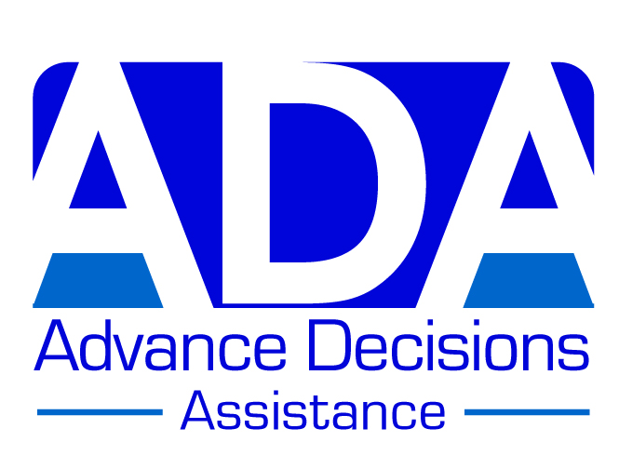

ADVANCE DECISION FORM (VERSION C)

This version is most suitable for someone who has a significant health problem, or a number of health problems, possibly including chronic and/or recurring conditions

Note to person completing this form: If this version is not quite right for you, remember that
you can personalise it by adding or deleting information. You may also like to look at the other versions on the ADA website: www.ADassistance.org.uk. Further information can also be found
on the website; or phone us if you have any questions: 01757 289453

This Advance Decision is intended to apply indefinitely unless I specifically revoke it.
I give permission for anyone legitimately involved in my care to read it.

Your name (block capitals): ……………………………………………………………………..

Your address: ………………………………………………………………………………………

………………………………………………………………………………………………………..

Your date of birth: ………………………….. Your NHS no. (if known): ………………………

Your GP’s name & address: ………………………………………………………………………

………………………………………………………………………………………………………..

Statement for you to sign:

If, for any reason, I am unable to make or communicate decisions about my medical treatment, I REFUSE all life-prolonging treatments/interventions, including (but not limited to):

(Specify here any treatments you particularly want to avoid, such as – for example –
chemotherapy, or further surgery.)

…………………………………………………………………………………………………..

…………………………………………………………………………………………………

If I experience a medical ‘emergency’, such as – but not limited to – a heart attack, stroke or traumatic brain injury, I REFUSE resuscitation and any other treatments/interventions which may prolong my life.

I maintain this refusal even if my life is shortened as a result.

However, in any of these circumstances, I do want pain relief and other palliative care as necessary to keep me comfortable and free from distress, even if my life is shortened as a result.

Continued on page 2

ADVANCE DECISION (VERSION C) PAGE 2 Your name: ………………………………

Your signature: ………………………………………….. Date: ………………………….

Witness signature: ………………………………………. Date: …………………………

Witness name & address: ………………………………………………………………………

……………………………………………………………………………………………………..

………………………………………………………………………………………………………

************

Note:
If you have – or may have - an impairment of the mind or brain (e.g. depression, anxiety, a learning disability), you should attach a statement from a health practitioner confirming that at the time of completing this Advance Decision, you have the mental capacity to make the decisions contained in it. [This ‘mental capacity statement’ – is also available on the ADA website, or we can send it to
you if you phone us on the number above.]

************

Advance Values Statement:
It will help doctors to understand and respect your wishes if you explain here why you do not want your life prolonged if you lose decision-making capacity in future (e.g. If you consider your current quality of life to be poor, relative to a quality of life you would consider worthwhile, explain in what ways this is so). You may choose (but do not need) to explain further the decisions you have made and the factors you have taken into account in making them, including what is important to you. You can add pages as necessary. [There are some examples of Advance Values Statements on the ADA website.]

