AFFIX A
PASSPORT PHOTO
HERE

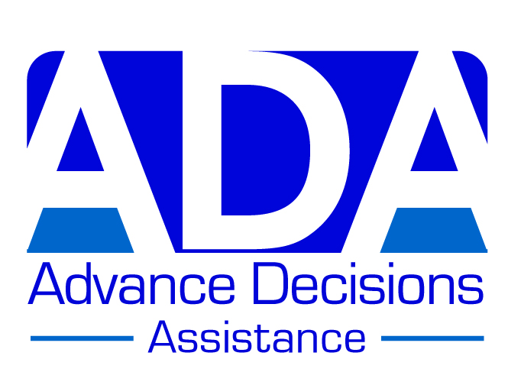

ADVANCE DECISION FORM (VERSION D)

This version is most suitable for someone with a recent diagnosis of dementia, or worried about dementia, and with other health problems

Note to person completing this form: If this version is not quite right for you, remember that
you can personalise it by adding or deleting information. You may also like to look at the other versions on the ADA website: www.ADassistance.org.uk. Further information can also be found
on the website; or phone us if you have any questions: 01757 289453

This Advance Decision is intended to apply indefinitely unless I specifically revoke it.
I give permission for anyone legitimately involved in my care to read it.

Your name (block capitals): ……………………………………………………………………..

Your address: ………………………………………………………………………………………

………………………………………………………………………………………………………..

Your date of birth: ………………………….. Your NHS no. (if known): ………………………

Your GP’s name & address: ………………………………………………………………………

………………………………………………………………………………………………………..

Statement for you to sign:

When I am unable to make or communicate decisions about my medical treatment, I wish to REFUSE all treatments/interventions which may prolong my life.

This refusal includes (but is not limited to):

- Cardio-pulmonary resuscitation (CPR)
- Ventilation
- Treatments designed to maintain or replace a vital bodily function
(such as a heart pacemaker)
- A feeding tube
- Antibiotics given for a potentially life-threatening infection
- Specialised treatments for particular conditions
(such as chemotherapy, dialysis, or insulin)
- Other current treatments/medications (if relevant) - say what these are:

…………………………………………………………………………………………………..

I maintain this refusal even if it shortens my life.
Continued on page 2

ADVANCE DECISION (VERSION D) PAGE 2 Your name: ………………………………

If I refuse food and/or drink by mouth, I refuse repeated attempts to feed/hydrate me;
or being persuaded or cajoled to eat or drink – even if this refusal shortens my life.

I do consent to treatment to alleviate pain or distress, even if it shortens my life.

Your signature: ………………………………………….. Date: ………………………….

Witness signature: ………………………………………. Date: …………………………

Witness name & address: ………………………………………………………………………

……………………………………………………………………………………………………..

………………………………………………………………………………………………………

************

(Delete note below if you have NOT been diagnosed with dementia.)

Important note:
Because I have recently been diagnosed with dementia, I have attached a statement from a health practitioner confirming that at the time of completing this Advance Decision, I have the mental capacity to make the decisions contained in it.

[This ‘mental capacity statement’ – is also available on the ADA website, or we can send it to
you if you phone us on the number above.]

************

Advance Values Statement:
You may choose (but do not need to) to include a further short statement here. This can explain
the decisions you have made and what is important to you. You can add pages as necessary.
[There are some examples of Advance Values Statements on the ADA website.]

