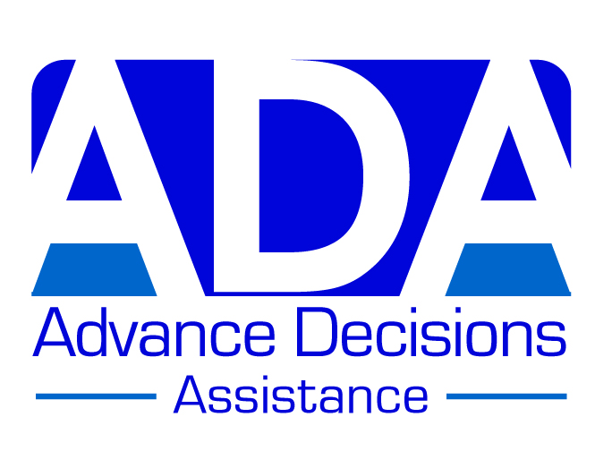

EXAMPLE AD – VERSION B

(Suitable for someone with a few health problems)

(B) BRIAN

Brian is 50 and generally healthy. However, he has Type 1 diabetes, and is dependent on insulin; and over the years he has suffered from bouts of depression, some of them quite severe and prolonged.

Brian is also concerned about medical conditions he may have inherited from his parents, both of whom had what Brian considers a very poor quality of life in their later years.

Brian is clear that he doesn’t want to be kept alive artificially if he has severe mental impairment (such that he cannot make his own decisions); and he doesn’t want to be admitted to a care home or to be so dependent on others that he needs 24-hour care. He does not consider this to be a worthwhile quality of life: for him, quality of life is more important than quantity of life.

*******************

Brian’s Advance Decision:

When I am unable to make or communicate decisions about my medical treatment, I refuse all treatments/interventions which may prolong my life.

This refusal includes (but is not limited to):

- Insulin for my diabetes
- Cardio-pulmonary resuscitation (CPR)
- Ventilation
- Antibiotics given for a potentially life-threatening infection
- A feeding tube

I maintain this refusal even if my life is shortened as a result.

I do consent to treatments/interventions to keep me comfortable and free from distress, even if my life is shortened as a result.

I have made these decisions because I would prefer to die rather than continue living without a quality of life that I consider worthwhile (see my Advance Values Statement below for what this means for me, and for the factors that have informed my decisions).

Important note:
Because I have in the past been diagnosed with depression, I have attached a statement from my GP confirming that at the time of completing this Advance Decision, I have the mental capacity to make the decisions contained in it.

Brian’s signature & date
Witness signature & date

Brian’s ‘Advance Values Statement’:

My decisions about my future are strongly shaped by what happened to my parents. My father had chronic heart and respiratory problems for most of his adult life, and suffered several strokes and heart attacks. My mother tried to look after him at home but really struggled and became exhausted. A major stroke when he was 65 left him completely unable to do anything for himself and he went into a care home, where he lived for another 7 years, needing constant care and with very little dignity. My mother never really recovered from caring for my father. Within a year of his being admitted to the care home, she was diagnosed with dementia, which progressed steadily. At first my brother and I tried to look after her, with the help of carers, but as she got more and more confused and frail, this became impossible, and there was no alternative but for her to go into a care home too. She died a year after my father, again with little dignity in her final years. Seeing them both like that towards the end of their lives, especially when they had been such vibrant people, was very hard to bear.

I am aware that heart disease and dementia both tend to be hereditary, so it seems a real possibility that I might be approaching that kind of a future. I want to do all I can to avoid it. In particular, I do not want to be totally dependent on others for all my needs, and to live out my days in a care home without really knowing or understanding what is happening to me. For me, a quality of life that I consider worthwhile involves a least a degree of independence, and the ability to attend to my own personal care (washing, dressing and toileting). And I consider quality of life much more important than quantity of life.

I have Type 1 diabetes and am dependent on insulin. I know that not taking insulin regularly will result in my death. I have decided that – once I lose the ability to communicate my medical decisions – I wish to refuse insulin. I would rather die relatively quickly (and sooner) with a diabetic coma than more slowly (albeit later) of something else. I want to minimise the risk of being kept alive with what I consider to be a poor quality of life, like my parents. In case I do not die with a diabetic coma, I have also refused the most common interventions for heart attacks, strokes and late–stage dementia.

*********************
*********************

Attached statement from a health practitioner (e.g. GP, dementia nurse, psychiatric social worker, IMCA)

I have discussed the content of this Advance Decision with … Brian X … and I am satisfied that he has the mental capacity to make the decisions contained in it. He understands what he is signing, has weighed the pros and cons of these
decisions, and can remember that he has made them.

Name: ……A Doctor…………………………………….

Signature: ……XXXX……………………………………. Date: …XXXX…

Role & contact information:

GP, The Surgery, Anytown ………………………………………………………………

Any other comments:

In my professional opinion, Brian was not depressed at the time he completed this

Advance Decision ………………………………………………..………………………

******************

