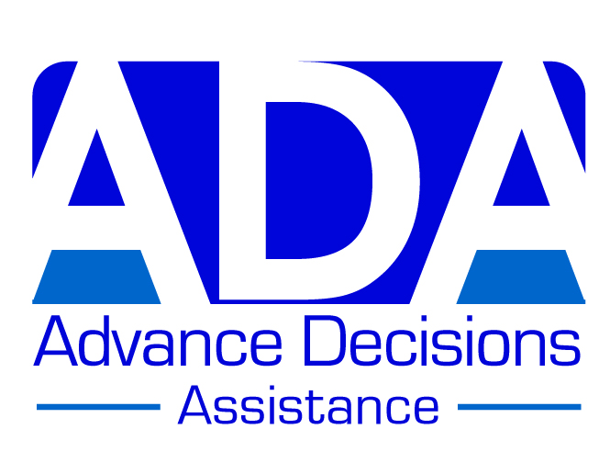

EXAMPLE AD – VERSION D

(Suitable for someone with a dementia diagnosis, or worried about dementia, and with other health problems)

(D) DAWN

Dawn is 82 years old and has just been diagnosed with Alzheimer’s disease. She knows that this condition is progressive and wants to plan for the future. She does not want to live for years with dementia, or to die in its late stages. She enjoys her independence and is filled with horror at the thought of moving to a care home. Her adult daughter says she will be only too happy to care for her, but Dawn doesn’t want to be a burden to her daughter.

Dawn also has high blood pressure, angina and heart problems and is at risk of having a heart attack or stroke. She hopes that by refusing treatment for her heart problems – as well as refusing to be resuscitated - she may die sooner of a heart attack or stroke than she would of dementia. She has discussed her Advance Decision with her daughter, who is very distressed that her mother is unwilling to live as long as is medically possible, and is planning for an earlier death.

**********

Dawn’s Advance Decision:

When I am unable to make or communicate decisions about my medical treatment, I wish to refuse all treatments/interventions which may prolong my life.

This refusal includes (but is not limited to):

- Cardio-pulmonary resuscitation (CPR)
- Ventilation
- Treatments designed to maintain or replace a vital bodily function
(such as a heart pacemaker)
- A feeding tube
- Antibiotics given for a potentially life-threatening infection
- Specialised treatments for particular conditions
(such as chemotherapy, dialysis, or insulin)
- Current treatments/medications
- - statins, blood pressure medication, angina medication

I maintain this refusal even if my life is shortened as a result.

If I refuse food and/or drink by mouth, I refuse repeated attempts to feed/hydrate me; or being persuaded or cajoled to eat and/or drink – even if this refusal shortens my life.

I do consent to treatment to alleviate pain or distress, even if it shortens my life.

I should like to die at home in my own bed, even if this shortens my life. I do not want to be rushed to hospital in my final days or hours.

Important note:
Because I have recently been diagnosed with dementia (Alzheimer’s Disease), I have attached a statement from my GP confirming that at the time of completing this Advance Decision, I have the mental capacity to make the decisions contained in it.

Dawn’s signature & date
Witness signature & date

**********

Dawn’s ‘Advance Values Statement’:

I am writing this Advance Decision in order to plan for the future, as best I can in an uncertain world. I have recently been diagnosed with dementia (Alzheimer’s Disease), and know that this will be progressive. However, I hope to avoid years of declining mental capacity, followed by a lingering death from advanced-stage dementia. I should prefer to die sooner, while I can still engage fully in, and take pleasure from, the aspects of life that I value. And I should like to die at home, in my own bed, if possible. I do not want to be rushed into hospital in my final days or hours.

The things that are important to me are my independence (I still live in my own home, with some occasional help), my social life (I am a member of several clubs and societies and have a small circle of good friends), and my hobbies (regular visits to the theatre and cinema, and volunteering for the National Trust). I am filled with horror at the prospect of moving into a care home and the restrictions and institutionalisation that would involve. Although my daughter has offered to care for me, I do not want to move in with my daughter and son-in-law when I can no longer look after myself. I don’t want to be a burden to her, particularly as she has a demanding job involving a lot of travel. I am well aware how much of a burden caring for an elderly relative with dementia can be: my niece did it for her aunt (my sister) in similar circumstances, and it nearly split the family apart.

I have a number of other health problems – high blood pressure, angina, and heart weakness and arrhythmia – and I am at high risk of having a strokes or heart attack. I have written my Advance Decision to refuse all treatments for these conditions, including resuscitation, once I am no longer able to make medical decisions for myself. My hope is that I may die sooner of a heart attack or stroke than I will of dementia, and that this will happen while I am still enjoying at least some of the things that are important to me, and before I need full-time care in an institution. For this reason, I have refused the medications I am currently taking for my heart and other problems, once I cannot make or communicate my own decisions about medication. I also do not want to be given any further specialised medications for these conditions (or any other medical conditions I might develop after losing my decision-making capacity). And, just in case I do not die of a heart attack or stroke, I have also refused the treatments and interventions that are common in late-stage dementia: antibiotics and a feeding tube. Please also note that I do not want to be ‘force fed’, however kindly.

Finally, I should perhaps mention that my daughter is very distressed that I am thinking about my death, and about the contents of this Advance Decision, which I have discussed with her – it seems she wants me to live for ever! I understand her feelings but please don’t let her wishes overrule what I’ve written here. This is my life and my choice. I am sorry to cause her pain and distress and hope that in time she will be able to overcome this, with the help of my son-in-law, who fully respects my choices.

I know what I want to happen and I am settled in these wishes.

**************
**************

Attached statement from a health practitioner (e.g. GP, dementia nurse, psychiatric social worker, IMCA)

I have discussed the content of this Advance Decision with … Dawn X … and I am satisfied that she has the mental capacity to make the decisions contained in it. She understands what she is signing, has weighed the pros and cons of these decisions, and can remember that s/he has made them.

Name: ………A Doctor……………………………

Signature: ………XXXXX…………………………… Date: …XXXX…

Role & contact information:

GP, The Surgery, Anytown ……………………………

Any other comments:

None………………………………………………………

