AFFIX A
PASSPORT PHOTO
HERE

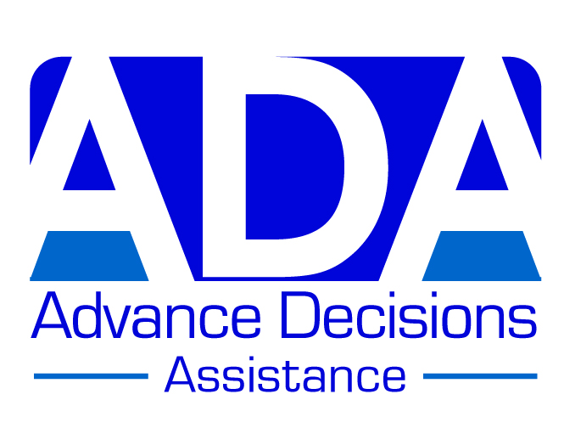

ADVANCE DECISION FORM (VERSION A)

This version is most suitable for someone who is healthy and active

Note to person completing this form: If this version is not quite right for you, remember that
you can personalise it by adding or deleting information. You may also like to look at the other versions on the ADA website: www.ADassistance.org.uk. Further information can also be found
on the website; or phone us if you have any questions: 01768 775566

Your name (block capitals): ……………………………………………………………………..

Your address: ………………………………………………………………………………………

………………………………………………………………………………………………………..

Your GP’s name & address: ………………………………………………………………………

………………………………………………………………………………………………………..

Statement for you to sign:

If, through accident, injury or illness, I have severe brain damage and am in a prolonged coma,
or a prolonged vegetative state (PVS) or minimally conscious state (MCS) – and if, in the opinion
of two qualified medical practitioners, I am unlikely to recover to a quality of life that I would consider worthwhile (see my values statement below) - then I REFUSE all treatments/interventions which may prolong my life. This refusal includes – but is not limited to - clinically-assisted artificial nutrition and hydration (CANH).

I maintain this refusal even if it shortens my life.

Your signature: ………………………………………….. Date: ………………………….

Witness signature: ………………………………………. Date: …………………………

Witness name & address: ………………………………………………………………………

……………………………………………………………………………………………………..

………………………………………………………………………………………………………
Continued on page 2

ADVANCE DECISION (VERSION A) PAGE 2 Your name: ………………………………

NOTE: If you have – or may have - an impairment of the mind or brain (e.g. depression, anxiety, a learning disability), you should attach a statement from a health practitioner confirming that at the time of completing this Advance Decision, you have the mental capacity to make the decisions contained in it. [This ‘mental capacity statement’ – is also available on the ADA website, or we can send it to you if you phone us on the number above.]

************

Values statement:
You should specify here what quality of life you consider worthwhile. You can also choose (but do not need to) to explain further the decisions you have made and what is important to you. You can add pages as necessary. [There are some examples of values statements on the ADA website.]

