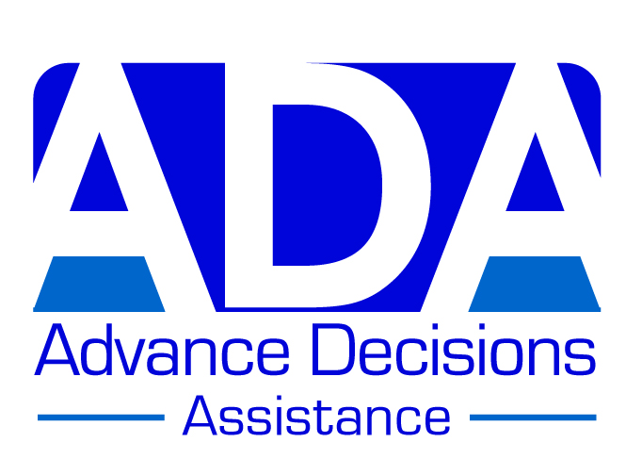

EXAMPLE AD – VERSION A

(Suitable for someone who is healthy and active – age doesn’t matter!)

(A) ANN

Ann is 25 years old and active in various sports. She has no major health problems. Her outdoor physical activities are a key part of her life.

Ann’s main concern is what might happen if she had a sporting accident that left her in a prolonged disorder of consciousness (coma, vegetative state or minimally conscious state) and therefore unable to decide on her own medical treatment.

Her Advance Decision refuses treatment in the case of a prolonged disorder of consciousness following an injury (or illness) which severely damages her brain.

*****************

Ann’s Advance Decision:

I refuse all medical treatments aimed at prolonging or artificially sustaining my life (including but not limited to clinically assisted nutrition and hydration) if:

(a) I am in a prolonged disorder of consciousness (coma, vegetative state or minimally conscious state)

and

(b) there is little prospect of recovery to a quality of life that I would consider worthwhile (see values statement below) in the opinion of two appropriately qualified doctors.

I maintain this refusal even if it shortens my life.

This Advance Decision is intended to apply indefinitely unless I specifically revoke it. I give permission for anyone legitimately involved in my care to read it.

Ann’s signature & date
Witness signature & date

Ann’s ‘Values Statement’:

I am a keen sportswoman, enjoying sailing and hiking in the summer and skiing, and snowboarding in the winter. I am aware that these activities – particularly the wintersports - involve a degree of risk, which I am more than willing to take because of the pleasure they give me. (I do wear a helmet!)

However, reading about the Formula One racing driver, Michael Schumacher’s skiing accident in 2014 (*link), which left him with severe brain injury after being in a coma for months, and from which it seems unlikely he will ever make a good recovery, really gave me pause. If anything remotely like that should ever happen to me, I do not want to be kept alive. That kind of ‘living death’ must be hell for him (if he is aware of it) and for his family. I would not want to put myself or my family through it, even without the glare of the media.

For me, recovery to a quality of life that I would consider worthwhile means being able to recognise and communicate with those I love, especially my partner and my sister (to whom I am close), and to be able to be involved in, and take pleasure in, their activities. While my physical competencies and independence are important to me, I could imagine and accept being less physically active than I am now, even being in a wheelchair and needing a substantial amount of care. I recognise that people change over the course of their lives and that ageing, and acquired disabilities, bring adaptations. What I absolutely could not accept is being mentally compromised to the extent I cannot even recognise, let alone communicate with, my family and friends.

I have therefore decided that if I am in a prolonged disorder of consciousness (coma, vegetative state or minimally conscious state), and if 2 doctors think I am unlikely to recover to this quality of life, then I wish to refuse any further life-prolonging treatment.

*******************

* http://www.telegraph.co.uk/sport/motorsport/formulaone/michael-schumacher/11677867/Michael-Schumacher-news-A-year-after-coming-out-of-coma-there-have-been-precious-signs-of-progress.html

*******************

